**VII. Promotion of the Model**

**8.1 The design of water control device**

**8.1.1 Introduction**

From model one and model two, we can know the optimal value of parameters to keep the temperature even throughout the bathtub and as close as possible to the initial temperature without wasting too much water. The parameters include the most water-saving shape of the bathtub, the suitable hot water speed and the temperature of the water in the bathtub. Therefore, we consider whether the difference temperature grade of water in the bathtub is corresponding to the hot water speed under the dynamic equilibrium of the water temperature in the bathtub?

**8.1.2 Implementation steps**

**Step1:** According to the model one and model two, we choose the value of those factors corresponding to the value of the best strategy.

**Step 2:** we set up different aimed tub water temperature, still use 50℃ hot water to heat the water, and use the same solution ways in model 1, we can gain the hot water speed corresponding to different aimed tub water temperature.

**8.1.3 Results and Analysis**

The results is shown as follows.

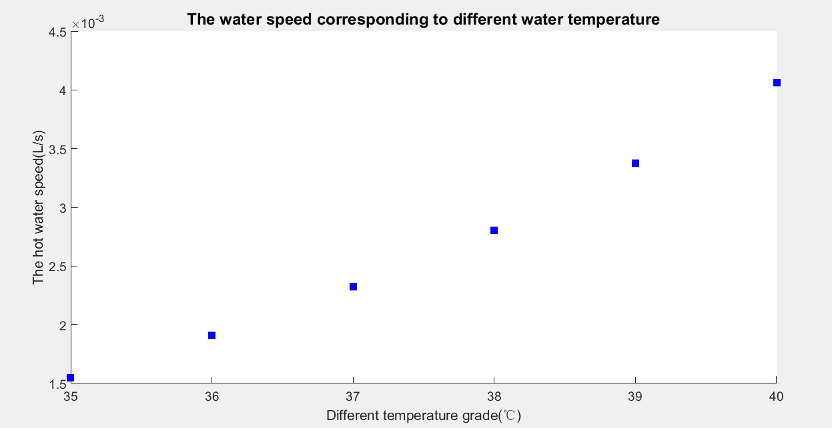

Figure . The hot water speed corresponding to different aimed temperature

What’s more, we design a convenient and automated device to control the speed of the hot water and the aimed temperature. The device has six levels as follows.

Table :The hot water speed corresponding to different aimed temperature

|  |  |  |
| --- | --- | --- |
| **level** | **The aimed temperature (℃)** | **The hot water speed(L/S)** |
| A | 35 | 0.001549 |
| B | 36 | 0.001908 |
| C | 37 | 0.002322 |
| D | 38 | 0.002728 |
| E | 39 | 0.003376 |
| F | 40 | 0.004061 |

**8.2 the best strategy to fill the empty bathtub**

Now, assume that we are going to fill the empty bathtub with 38℃ bath water. As we have discussed in model 1, when the volume of water in the bathtub increases, the heat transfer area will increase, and there will be more heat loss.

The temperature of water in the tub is always lower than 38℃ during the process of filling the bathtub. So the process of 38℃ bath water flowing into the bathtub can be seen as a heating process. Using the same solution as model one, we do a iteration to stimulate the change of water temperature and the volume of water in the bathtub. Through MATLAB programming, we can get the result as figure show:

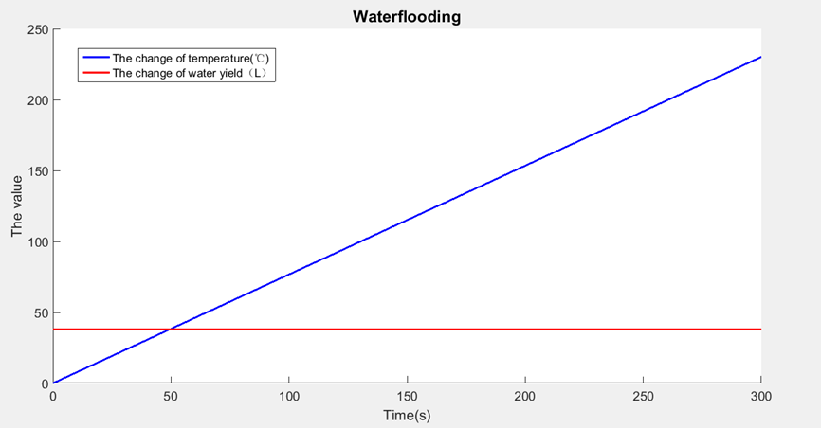

Figure :The change of temperature and volume of the water in the bathtub

As we can see from figure ,as the volume of water in the bathtub increases, the temperature will change little. So we can conclude that what degree of bath water you want, just setting the temperature of hot water flowing into the bathtub as the temperature you want.